2253 CFGS Web Application Development

Module 2 – Data Bases

UF2 – SQL Language: DDL and DML
NF4 – Data Manipulation Language
ACTIVITY

ACTIVITY DONE BY  Aaron Andal | 1DAW

Activity 6: Data Manipulation Language

Description

1. Implement next SQL DML statements in HOSPITAL database.

The Entity-Relationship:

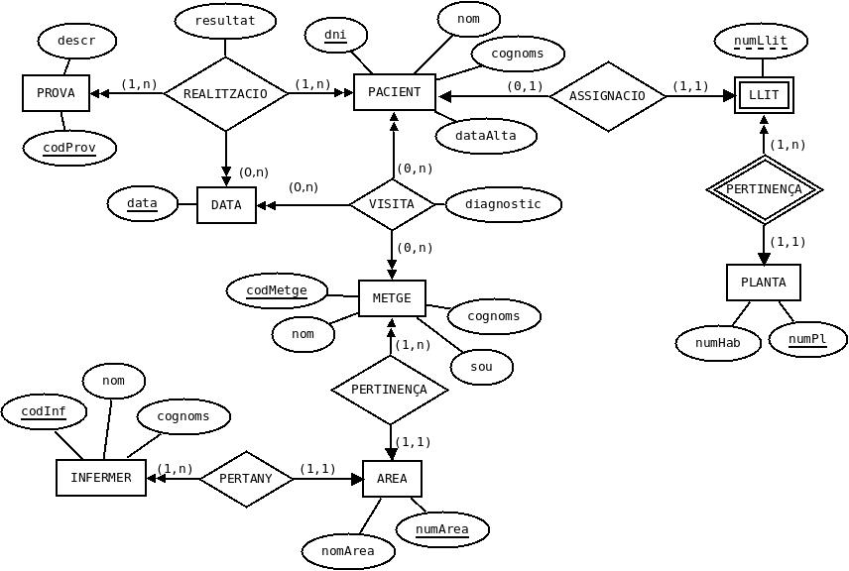
And the relational model:

AREA (numArea, nomArea)

PROVA (codProv, descr)

PLANTA (numPl, numHab)

LLIT (numPl, numLlit)
ON {numPl} REFERENCIA PLANTA

PACIENT (dni, nom, cognoms, dataAlta, numP, numL)
ON {numP,numL} REFERENCIA LLIT (numPl,numLlit)

METGE (codMetge, nom, cognoms, sou, numArea)
ON {numArea} REFERENCIA AREA

INFERMER (codInf, nom, cognoms, numArea)
ON {numArea} REFERENCIA AREA

VISITA (dniPac, codMetge, data, diagnostic)
ON {dniPac} REFERENCIA PACIENT(dni)
i {codMetge} REFERENCIA METGE

REALITZACIO (codProv, dniPac, data, resultat)
ON {codProv} REFERENCIA PROVA
i {dniPac} REFERENCIA PACIENT(dni)

- Show a list of all the areas with the number of doctors in every area. Attention: there is a doctor who is not assigned to an area.

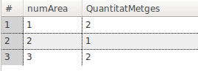
SELECT METGE.numArea, COUNT(METGE.nom) "QuantitatMetges" FROM METGE GROUP BY METGE.numArea HAVING METGE.numArea IS NOT NULL;
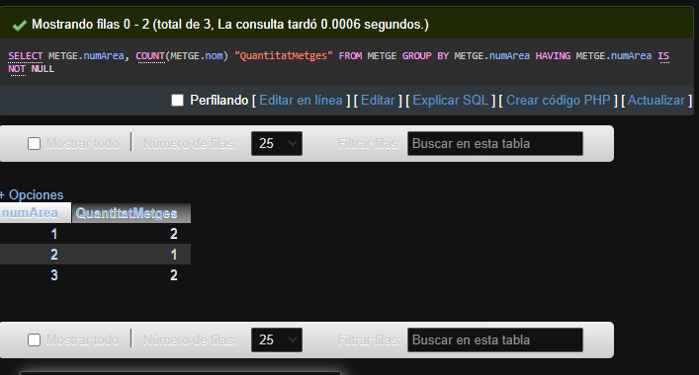

- Show a list of all the floors with the number of patients in every floor.
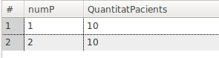
SELECT PACIENT.numP, COUNT(PACIENT.nom) "QuantitatpACIENTS" FROM PACIENT GROUP BY PACIENT.numP;

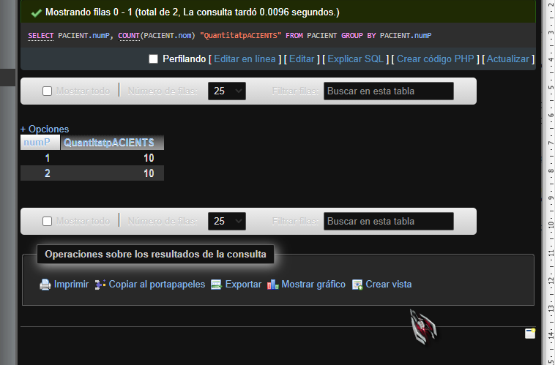

- Show a list of all the areas with the maximum salary, minimum salary, average salary and sum of the salaries by area. Attention: there is a doctor who is not assigned to an area.

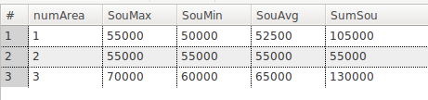
SELECT METGE.numArea, MAX(METGE.sou), MIN(METGE.sou), AVG(METGE.sou), SUM(METGE.sou) FROM METGE GROUP BY METGE.numArea HAVING METGE.numArea IS NOT NULL;

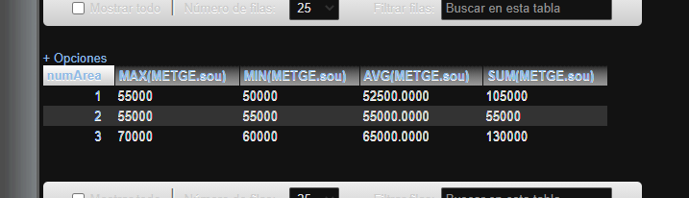

- Show a list of the floors (fllor number and amount of patients) with more than 4 patients.

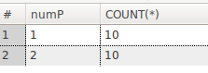
SELECT PACIENT.numP, COUNT(PACIENT.nom) FROM PACIENT GROUP BY PACIENT.numP HAVING COUNT(PACIENT.nom) > 4;
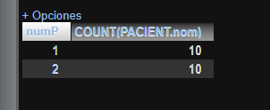

- Show the information of all the doctors who earn more than Carles Vila.

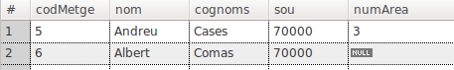
SELECT * FROM METGE WHERE METGE.sou > (SELECT METGE.sou FROM METGE WHERE METGE.cognoms = 'Vila');
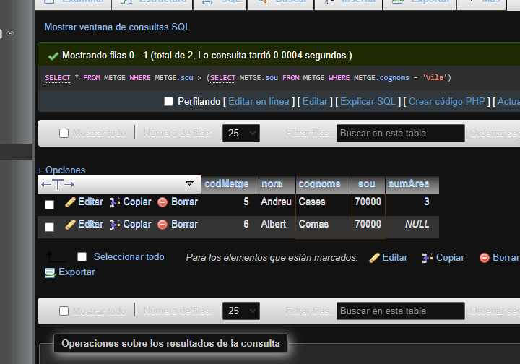

- Show the information of all the doctors who earn more than the average of all the hospital.

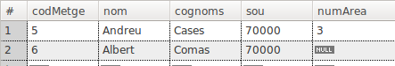
SELECT * FROM METGE GROUP BY METGE.nom HAVING AVG(METGE.sou) > SUM(METGE.sou)

- Show codes and names of the areas where there are doctors assigned to this area who earn more than the budget of the area.

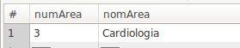

- Show codes and names of the areas where the salaries of all the doctors assigned to this area are lower than the budget of the area.

